1. **Surface Model**

The ground surface file has been added to the share folder 🡪 two LiDAR folders Arrowsmith/Model parameters/LiDAR_Projects_LGATE_351_WA_GDA94_Public_FileGeodatabase

1. **Geological Model**

Geo model domain (shapefile) 🡪 Arrowsmith/Model parameters/Otorowiri_Model_Extent

Borehole information (from hydro conceptualisation) 🡪 Arrowsmith/Model parameters/Otorowiri_Model_Geology

Fault traces 🡪 N/A for now (they make up the eastern and western model borders 🡪 perhaps this can be played around with in the boundary conditions?)

Fault displacement 🡪 N/A for now (the Eneabba Fault is a hinge fault that disappears somewhere between the southern and norther extents of the model)

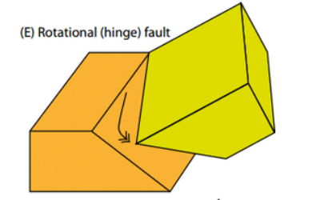

* 1. **Structural setting of the northern Perth Basin**

The structural architecture of the Perth Basin is the product of oblique rifting during the Permian, Late Triassic to Early Jurassic and Middle Jurassic to Early Cretaceous, superimposed over pre-existing basement terrains. Extension during the Permian produced a series of deep (up to 15km), north-south trending rift basins (Bunbury Trough and Dandaragan Trough) along the western margin of the Yilgarn Craton. The Abrolhos Sub-basin represents a northwestern branch of the Permian rift system formed along the southwestern margin of the Northampton Complex, which is separated from the **Dandaragan Trough** by an intra-basin high represented by the Beagle Ridge, Dongara Terrace and Greenough Shelf.

* The final rift and breakup phase in the **Middle Jurassic to Early Cretaceous** was associated with deposition of fluvial and marine siliciclastics (Yarragadee Formation, Parmelia Group and Warnbro Group)
* **Breakup during the Early Cretaceous (Valanginian -** between 137.05 ± 0.2 Ma and 132.6 ± 0.2 Ma**)** was associated with widespread inversion, erosion, strike-slip tectonics and volcanism, which significantly modified the structural architecture of the Perth Basin. Major structural elements associated with breakup tectonism include an area of inverted Permian half graben in the Turtle Dove Ridge and the Zeewyck Sub-basin which formed in a zone of strike-slip faulting along the Turtle Dove Transfer.

**Fault systems:** The major north–northwest-trending faults that formed during the formation of the basin are normal faults and these have been grouped into three fault systems (Mory & Iasky 1996). From east to west, these are: the Darling Fault system (Darling, **Urella** and Muchea faults), the Eneabba Fault system (**Eneabba** and Coomallo faults), and the Beagle Fault system (Beagle, Mountain Bridge and Beharra Springs faults). As these regional faults form long linear features, a component of strike-slip movement can be implied (Lowell 1985; Middleton 1991; Crostella 1995). Intracratonic sedimentation commenced in the Early Permian, with the melting of the Gondwana ice cap and the subsequent rise in sea level. Throughout the Permian time, north-trending regional growth faults marked the progressive rifting of the basin (Crostella, 1995).

* About half of the throw of the Darling Fault north of the Barberton Terrace has been relayed to the Muchea Fault (Mory & Iasky 1996). The throw on the Darling Fault decreases north of the Abrolhos Transfer Fault, which is compensated by an increased throw on the parallel **Urella Fault** (Mory & Iasky 1996). The **Eneabba Fault** has a throw of several hundred metres at its northern limit, decreasing towards the south (Crostella 1995).
  + The thickest sediments of the northern Perth Basin are found in the **Dandaragan Trough**, a large syncline between the Darling Fault (or **Urella Fault** at its northern maximum) and the **Eneabba Fault** (Crostella 1995), where the depth to basement is up to 15 000 m (Figure 17).
* The Darling Fault system (including the **Urella Fault**): This fault system originated as a shear zone during the Archean (Blight et al, 1981; Dentith et al, 1994) and was reactivated to form a major rift-border fault to the incipient Perth Basin during the Cisuralian (Crostella and Backhouse, 2000).

<https://www.ga.gov.au/scientific-topics/energy/province-sedimentary-basin-geology/petroleum/offshore-southwest-australia/perth-basin>

Wilde, S.A. (1999). Evolution of the Western Margin of Australia during the Rodinian and Gondwanan Supercontinent Cycles. Gondwana Research 2(3): 481-499.

* 1. **Lithology/sedimentary characterisation**

**Yarragadee Formation:** Middle to late Jurassic, predominantly sand unit, consisting of interbedded sandstone, siltstone, shale, and claystone beds with minor conglomerate. Sediments were deposited in a non-marine fluvial environment, with shale sections possibly representing a lacustrine or overbank setting (Mory & Iasky 1996). Facies analysis of petroleum well Gingin 1 near Gingin indicates that the Yarragadee sediments were deposited in a perennial braided river system with a high sediment load.

In outcrop, the Yarragadee Formation is typically oxidised to considerable depths. Oxidation was observed as deep as 400 m below the surface along the Watheroo Line, between 100 and 200 m along the Eneabba and Dongara lines (Commander 1981; Irwin 2007), and to some distance below the watertable in the Allanooka area (Allen 1980). In the oxidised zone, the formation is white, cream, red or yellow-brown in colour. Feldspar within the weathered zone is altered to kaolin clay, pyrite is oxidised to ferruginous layers or nodules, and a laterite profile is often developed at the surface (Allen 1980).

Pennington Scott (2010) defined and informally referred to them as units A, B, C and D, in order of oldest to youngest. Units A and C contain predominantly sandstone sequences and are predominantly fluvial deposits. Unit A contains about 30 per cent siltstone and shale beds, but these are only minor in Unit C. Unit B contains 60–70 per cent siltstone and shale and are interpreted as lacustrine deposits. Unit D comprises up to 80 per cent fine-grained sediments that probably represent lacustrine deposits.

* **Unit B**: The siltstone in Unit B is grey with thin laminations of very fine, well-cemented, argillaceous sandstone (Johnson 1965) grading to claystone and shale that is dark brown-grey, micaceous, carbonaceous and pyritic that are up to about 20 m thick. The sandstone in Unit B is similar to that in units A and C; poorly to moderately sorted, angular to subangular, feldspathic with moderate development of siliceous cement. Kaolin clay is common, and is more abundant in the lower part of the unit. The sandstone also has coal laminae. A thicker sandstone interval is present within the central portion of the unit and is typically 100–200 m thick.
* **Unit C**: Unit C is a distinctive, thick sandstone sequence that overlies the shale and claystone of Unit B. Unit C comprises about 80 per cent sand. The sandstone is a light brown to light grey, medium to very coarse grained quartz sand with fine-grained intervals, with some gravel and pebbles and minor feldspar. It is poorly to well sorted (but mainly moderately sorted), subangular to subrounded, and mostly unconsolidated. There is minor kaolin clay in the matrix, minor siliceous cementation, and rare thin beds of grey to brown-grey, micaceous, slightly carbonaceous siltstone and black coal.
* **Unit D**: Unit D is a sequence of interbedded sandstone, claystone and siltstone overlying Unit C. The sandstone within the upper portion of Unit D is white to light grey and pale greenish grey, silty to fine grained, friable to hard, silty in part, with a kaolin clay matrix. It is variably calcareous, rarely grading into light brown sandy limestone with occasional beds of loose, coarse to very coarse quartz sand. Deeper in the unit, the sandstone is fine to very coarse grained, moderately to poorly sorted, subangular to subrounded, with some siliceous cement. Intervals of silty, fine-grained sand similar to the upper sandstone are also present. There is minor brown to black coal, and occasionally pyrite. Much of the deeper sandstone contains a portion of silt and kaolin clay that is not always apparent in mud rotary drill samples. Interbedded siltstones are light to dark brown-grey, grading to dark brown-grey claystone that is soft to firm. Siltstone and claystone are dominant within the upper part of Unit D as far north as the Eneabba Line.

**Parmelia Group**: consists of sandstone, siltstone and shale that were deposited across the east of the northern Perth Basin in a fluvial to lacustrine environment during the Early Cretaceous. The name Parmelia Group was proposed by Crostella and Backhouse (2000), while previous member units of the Parmelia Formation, as defined by Backhouse (1988), were recognised as new formations. The group was previously described as part of the Yarragadee Formation (Playford et al. 1976). The formations within the Parmelia Group identified in offshore oil exploration wells are, in ascending order: the Otorowiri Formation, the Jervoise Sandstone, the Carnac Formation and the Charlotte Sandstone.

* **Otorowiri Formation**: the most widespread formation and forms the base of the Parmelia Group, and its outcrop can be traced from Mingenew to Dandaragan. In the south and centre of the area, the Otorowiri Formation is overlain by the shaley Carnac Formation. In the north and to the east, the Otorowiri Formation is overlain by an interbedded sand and subordinate shale, which is not found offshore. The Jervoise and Charlotte sandstones have not been recognised onshore. It is often difficult to distinguish the various formations above the Otorowiri Formation onshore, particularly in the Dandaragan and Beermullah troughs, and they are referred to as ‘undifferentiated Parmelia Group’ in this bulletin.
* The Otorowiri Formation comprises shale and siltstone with minor thin beds of fine-grained sandstone. The shale and siltstone is finely laminated, predominantly dark grey to greenish-grey, and micaceous, while the sand is glauconitic and pyritic (Playford, et al. 1976). In the Eneabba Line, there are two distinct siltstone beds separated by a thin sand horizon (Commander 1981).

**\*\*\*Noted to be the most distinct between the Arrowsmith River and the Eneabba Line, so I think the division lines for the model are nice\*\*\***

* 1. **Geological model extents**

The northern extent of the model corresponds to the Dongara Line: DL3, DL4, and DL5.

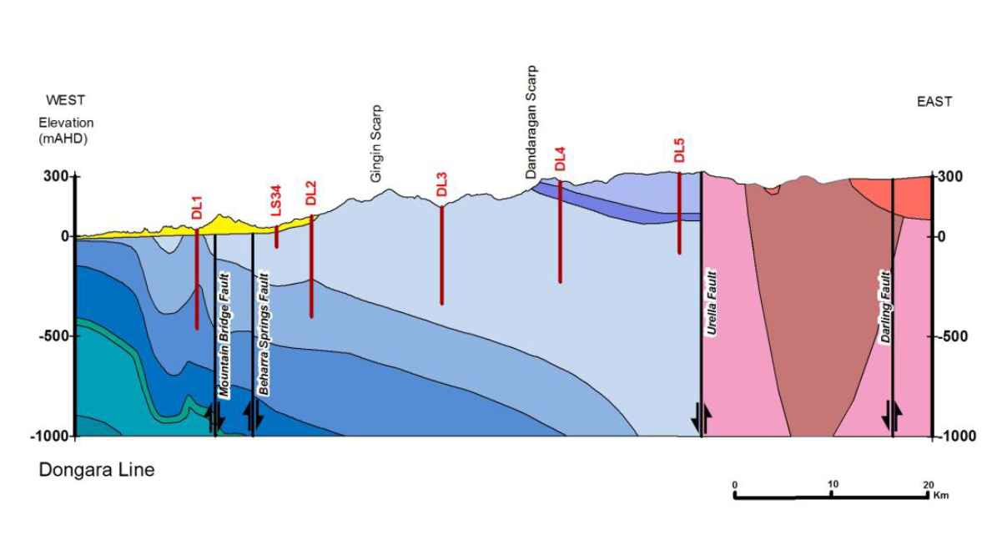The eastern extent is set by the Urella Fault (not necessary to bring in the changing geology – this is crystalline basement). The western extent was set to be the Gingin Scarp, which roughly correlates the to Coomallo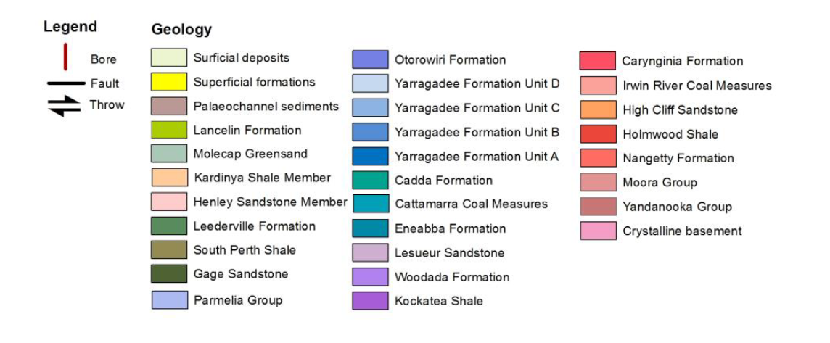 Fault in the southern portion of the geological extents and would create a boundary for surface water as well. The Coomallo Fault offsets the Upper Yarragadee (Units C and D) with the Lower Yarragadee (Units A and B). The southern boundary of the geological model is set by the Eneabba Line bores (EL5, EL4, EL3, EL2, and EL1).

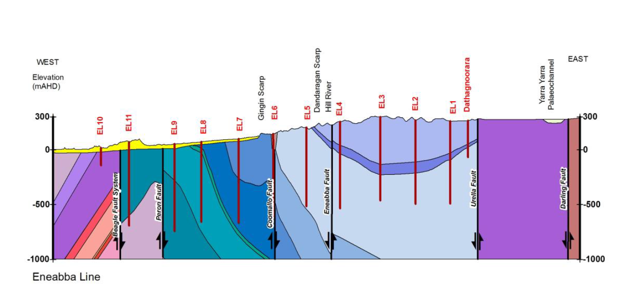

The geological model is supplemented by deep oil and gas exploration bores where available and select deeper boreholes from the Arrowsmith Scheme investigation.

* 1. **Geological timeline in the model domain**
* Concerning only the geological block that I’ve defined, which will only go to a depth of about 700m – reaching only Yarragadee Unit B, which is not defined in any of the boreholes.
* Naming convention: Sedimentary layers (S0, S1, S2, etc.), Deformation (D1, D2), Folds (F1, F2), Metamorphic events (M1, M2), and Intrusions (I1, I2)

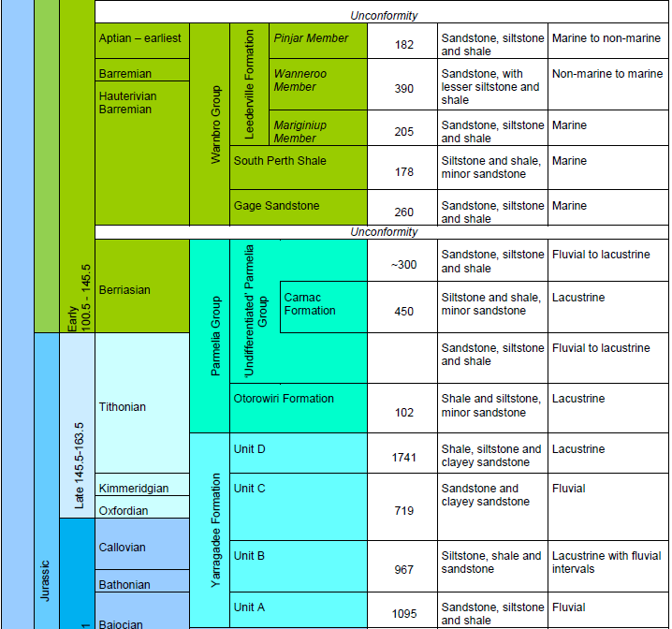

* **D1:** Urella Fault (as part of the Darling Fault system) was reactivated to form a major rift-border fault to the incipient Perth Basin during the Cisuralian (298.9 ± 0.15 Ma – 272.3 ± 0.5Ma) – this is the Early Permian. This is the beginning of the Gondwana breakup, which affects the Perth Basin in phases. The final rift and breakup phase in the **Middle Jurassic to Early Cretaceous** was associated with deposition of fluvial and marine siliciclastics (Yarragadee Formation, Parmelia Group and Warnbro Group).
  + **Interpretation:** deposition was possible because of the faulting offset over this period
* **S0:** Yarragadee Formation Unit B, deposited in lacustrine environments, with periods of deltaic and fluvial influence. Bathonian (168.2 ±1.2 Ma - 165.3 ±1.1 Ma) to early Callovian (165.3 ± 1.1 Ma - 161.5 ± 1.0 Ma) age
* **S1:** Yarragadee Formation Unit C, deposited in a fluvial and alluvial setting during a tectonically active period accompanied by a large influx of sand. Callovian (165.3 ± 1.1 Ma - 161.5 ± 1.0 Ma) to Kimmeridgian (154.8 ±0.8 Ma - 149.2 ±0.7 Ma) in age.
* **S2:** Yarragadee Formation Unit D, deposited in a lacustrine environment with fluvial interruptions. Unit D is absent over the western onshore portion of the basin, where it has probably been fully eroded by the breakup unconformity. Tithonian (149.2 ±0.7 Ma - 143.1 ±0.6 Ma) in age.
* **S3:** Otorowiri Formation, deposited in a lacustrine environment, with some periods of marine lagoonal conditions. Late Jurassic Tithonian (149.2 ±0.7 Ma - 143.1 ±0.6 Ma) age.
* **F1:** Syncline formation after deposition of all conformable sedimentary layers – **assumed** since all the layers look to follow the same syncline and are listed everywhere as a conformable sequence. Maybe related to theValanginian(137.05 ± 0.2 Ma - 132.6 ± 0.2 Ma) phase of breakup, which was associated with widespread inversion, erosion, strike-slip tectonics and volcanism, significantly modifying the structural architecture of the Perth Basin.
* **D2:** Eneabba Fault cross-cutting all folded layers – again, this is **assumed** to be associated with the later phases of breakup deformation, maybe Valanginian (137.05 ± 0.2 Ma - 132.6 ± 0.2 Ma) but superseded by the syncline formation.

1. **Hydrogeological information**

Groundwater levels are available from mainly EL series bores (southern boundary), DL bores (northern boundary), Wilson Nature reserve, and Arrowsmith River bores. Data stretches from 1967 onwards.

* Water levels in the region have gone up due to deforestation (reduction in net loss to vegetation). Since then they have stabilised, and perhaps will be impacted by the changing climate/drying conditions.

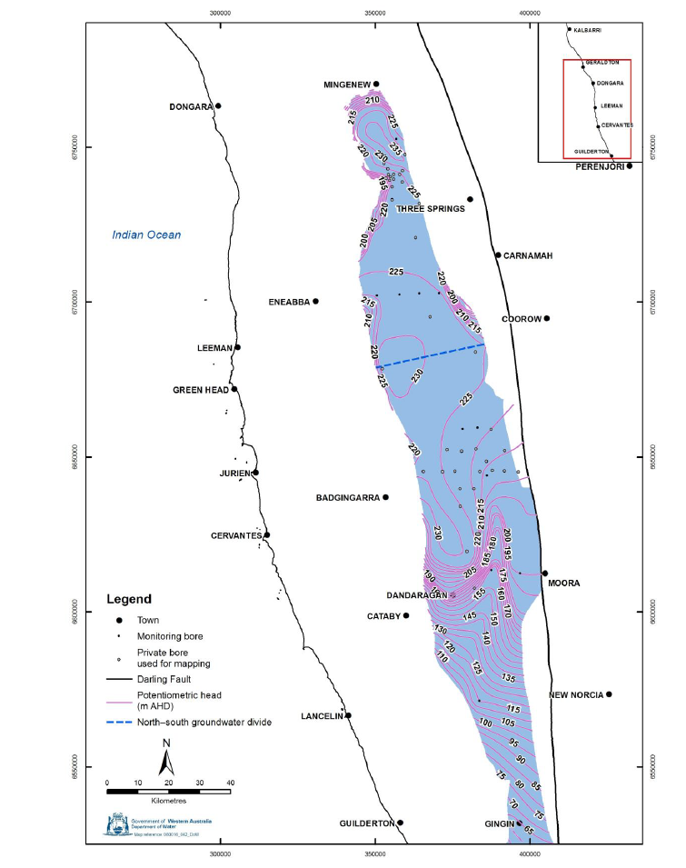

Potentiometric head in the Leederville-Parmelia aquifer shows north-east outlet over the Otorowiri outcrop

* Model extent should be from the groundwater divide in the south to the edge of the Leederville-Parmelia in the north (Mingenew).

1. **Kerry paper on using Modflow to model sedimentary structures**
   1. **Vocabulary and modelling background**

* FE 🡪 finite element; FV 🡪 finite volume; FD 🡪 finite difference
* CVFE 🡪 control volume finite element
* CVFD 🡪 control volume finite difference
* TPFA 🡪 two-point flux approximation; has an inherent orthogonality assumption whereby the conductivity tensor must align with cell boundaries.
* MPFA 🡪 multi-point flux approximation; utilizes multiple neighbouring cells to construct gradient terms, which allows more rigorous treatment of irregular cell geometries and directional anisotropy.
  1. **Paper notes and outcomes**
* Modflow has historically been limited to Cartesian discretization and a two-point finite-difference scheme, which is not suitable for geometrically complex hydrogeological units as uses TPFA – this causes problems when structures and their conductivity tensors are nonuniformly tilted in the vertical direction, and when their irregular shape becomes significantly rasterized when mapped onto a structured grid.
* DISU and GNC packages of MODFLOW-USG allow for flexible and unstructured gridding, and corrections for discretization that does not comply with CVFD requirements. This has recently been combined the XT3D capability which solves the groundwater flow equation using CVFD with a 3D MPFA.
* Theoretical investigation of tilted sand channel in a low conductivity domain, where the head gradient follows the channel direction.

* Diagonal head gradients are well represented for rectilinear and flexible grids, but vertically offset grids are not yet suitable for steeply dipping heterogeneous layers where a diagonal head gradient is imposed.

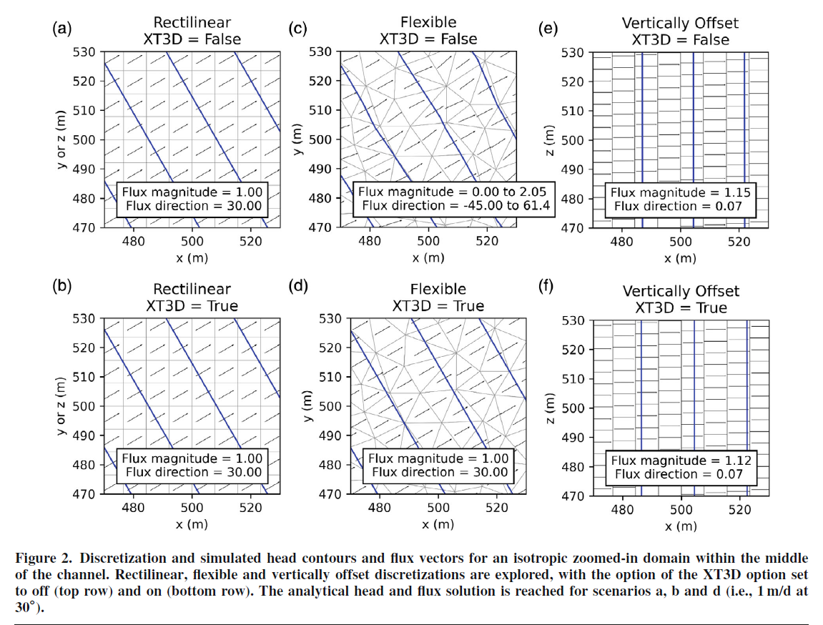

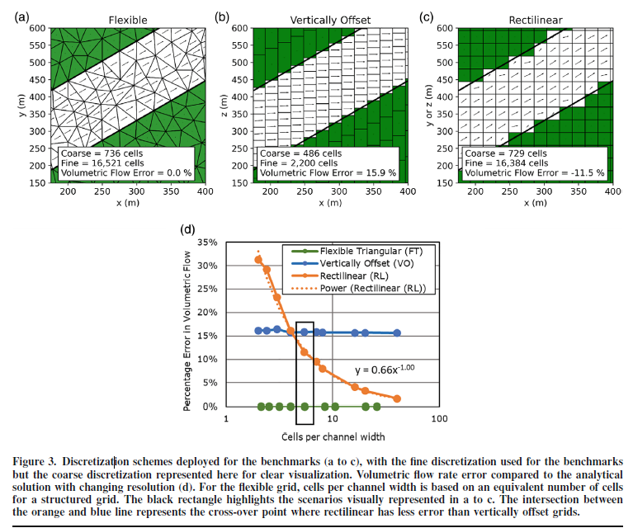

1. **Hydrogeological Question and Investigation**

Permanent surface water expression (pools) in this area is often conceptualised to be correlated to the Otorowiri Formation confining layer.

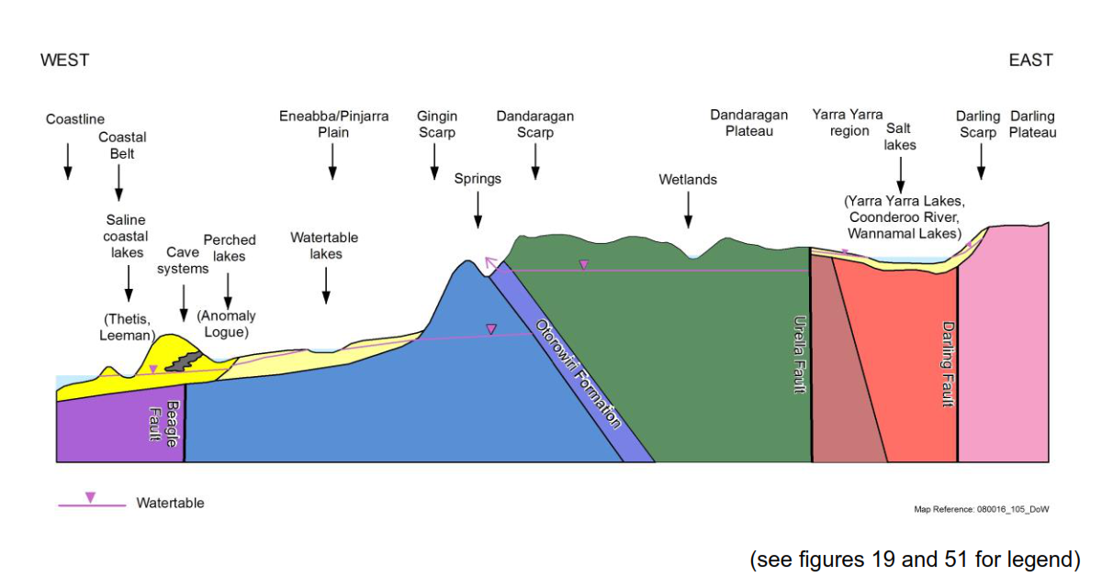

Otorowiri Spring is just one of the examples of this kind of location, but actually there are several places with similar environments that are projected to host GDEs (Rutherford, 2005).

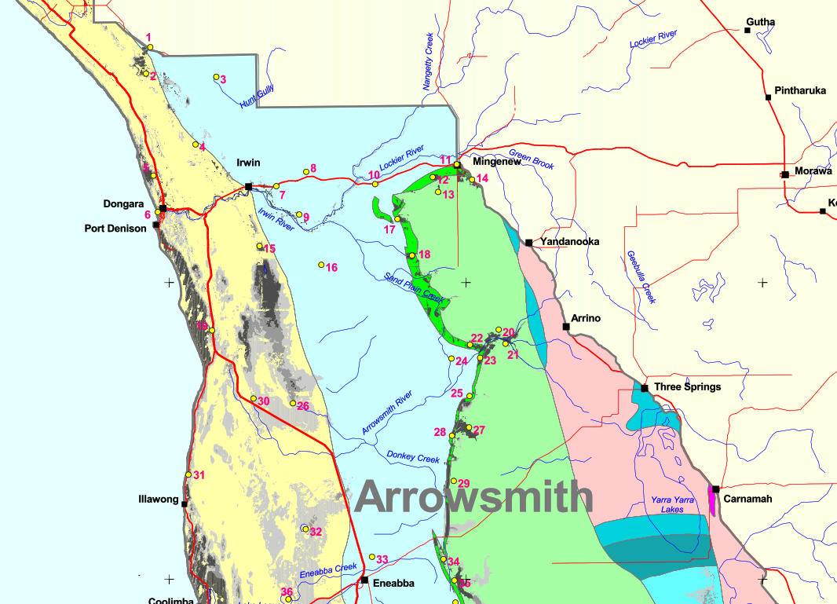

The **bright green in this figure is where the Otorowiri Formation outcrops to the surface** – many of the predicted GDE placements are along this outcrop. The Wilson Nature Reserve area (and Otorowiri springs) is in the red box.

* Can we simulate flow conditions through the Parmelia which will result in these surface water features?
* What impact does local heterogeneity (increased clays, etc.) have?